Notes on the IoB design

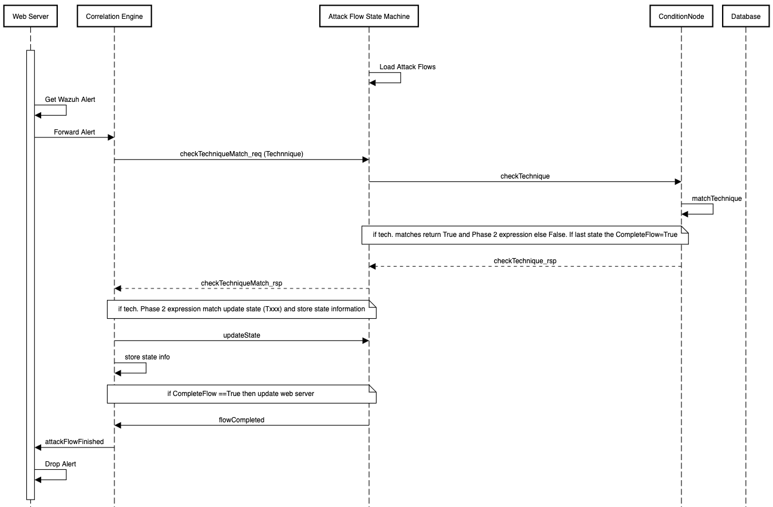

- The correlation rules are to be stored in the ConditionNodes. This means the AttackFlow file (.afb) must be updated and the expressions transferred to the CondiditonNode objects. Since these only have on Pattern field the correlation rule expression may need be combined. The flow should then be published as json and the AttackFlow and ConditionNode code updated to implement new changes. Changes must be validated using current set up. (Xi)
- The interface methods as described in the diagram are to be specified (Xi) and implemented (both)
- Validation -I want to validate this in two steps
  - Using CURL – each attack step must have a curl statement created that can be used to manually verify the operation of the state machine to completion (Shiyu)
  - Using Wazuh – this means the AtomicRed attack scripts are to be run , the alerts forwarded to the webserver and the attack flow verified. I suspect this will take some work. (Both)

- The system must be extended to deal with the generation of STIX objects. Ideally this requires the design of a new class – in fact design is missing an overall control flow class – we can use the webserver to do this of course (but it is not classic design solution). Afaik the STIX classes we need are Behaviour and Detection (highest priority) as well as Attack Pattern and Detector. Most of these classes are not implemented in the python stix library and were manually created by OCA using their stix2neo4j (my name) tool. This task needs further investigation. (Xi)
- The tasks to collect the STIX data are:
  - Design of the control flow (web server is default)
  - Identification of the data that is needed for each STIX object type
  - Design of how to collect and store this data. We want to capture the relationships as well e.g. the “occurs_before” relationship in the IoB will be captured by the sequence of the attack flow states so this should be retained. I can imagine three approaches to this
    - Use the Attack Flow to store the data since it already has the relationships. Redis or something similar would be used
    - Use the Sanic web context - task is therefore to design the data structure (I would do it this way)
    - The existing node4j could be used
This task is tbd Shiyu.

